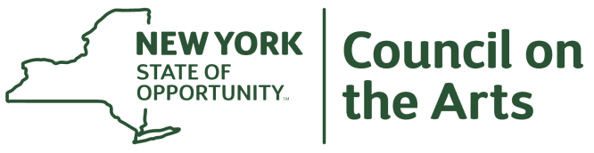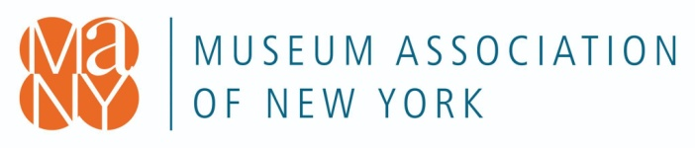

June 8, 2022

FOR IMMEDIATE RELEASE

Contact:
Cheryl Learned: 518-483-7285, or Anne Marie Wiseman: 518-681-9003
Megan Eves, Assistant Director for Programs and Communications
518-273-3400 | meves@nysmuseums.org
Franklin County Historical & Museum Society Awarded $5000 from NYSCA and MANY Partnership Grants for Capacity Building

Location: Box 388, 51 Milwaukee Street, Malone, NY 12953

The Franklin County Historical & Museum Society has received a grant to help reach out to the communities of Franklin County. The money will be used to provide infrastructure allowing them to communicate digitally throughout the county. The technology at the museum will be upgraded to include new computers, scanner hookups and tech support.

The Museum Association of New York (MANY) in partnership with the New York State Council on the Arts (NYSCA) awarded a total of $500,981 to 102 grantees to assist New York museums with capacity building.

“We thank NYSCA for this partnership and this opportunity to rapidly distribute much-needed funding to New York’s museums,” said Erika Sanger, Executive Director, MANY.

“This grant will greatly enhance our ability to work with county school systems to provide remote learning about Franklin County history. The technology, combined with the creativity of our volunteers, will increase access to the museum’s artifacts and archives for all interested online visitors,” according to Cheryl Learned, co-president.

This grant partnership with NYSCA was developed in direct response to the Institute of Museum and Library Services (IMLS) and Partners for Public Good (PPG) study “Market Analysis and Opportunity Assessment of Museum Capacity Building Programs” report published in March 2021.

Capacity Building grants were awarded in amounts up to and including $5,000 to help museums respond to pandemic-related challenges, build financial stability, strengthen board and community engagement, update technology, support leadership, and change systems to address diversity, equity, access, inclusion, and justice. Awards were made to museums of all budget sizes and disciplines.

“The arts and culture sector is facing a multi-year recovery process after two years of unimaginable challenges,” said Mara Manus, Executive Director, NYSCA. “We are grateful to MANY for their stewardship of this opportunity that will ensure New York State museums continue to grow and thrive. We send our congratulations to all grantees on their awards.”

Partnership Grants for Capacity Building are made possible by the New York State Council on the Arts with the support of the Office of the Governor and the New York State Legislature.

# # #
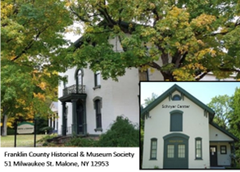
The Museum will once again be open to visitors Tuesday-Friday 1-4:00pm, June 7-Sept 2.

The Schryer Center for Genealogical Research will be open Tuesdays and Thursdays 11am-4pm, starting June 14. You may also call 518-483-2750 to make an appointment at any time.

About the Museum Association of New York

The Museum Association of New York is the only statewide museum service organization with more than 700 member museums, historical societies, zoos, botanical gardens, and aquariums. MANY helps shape a better future for museums and museum professionals by uplifting best practices and building organizational capacity through advocacy, training, and networking opportunities. Visit www.nysmuseums.org and follow MANY on Facebook, Twitter, Instagram, and LinkedIn @nysmuseums

About the New York State Council on the Arts

The Council on the Arts preserves and advances the arts and culture that make New York State an exceptional place to live, work, and visit. The Council upholds the right of all New Yorkers to experience the vital contributions the arts make to our communities, education, economic development, and quality of life. Through its core grant-making activity, the Council on the Arts awarded more than $100 million in FY 2022. NYSCA's statewide grants program supports the visual, literary, media and performing arts and includes dedicated support for arts education and underserved communities.

The Council on the Arts further advances New York's creative culture by convening leaders in the field and providing organizational and professional development opportunities and informational resources. Created by Governor Nelson Rockefeller in 1960 and continued with the support of Governor Kathy Hochul and the New York State Legislature, the Council is an agency that is part of the Executive Branch. For more information on NYSCA, please visit http://www.arts.ny.gov, and follow NYSCA's Facebook page, Twitter @NYSCArts and Instagram @NYSCouncilonthe

